Email: Karlalopezsan@g.ucla.edu  Phone: (323)501-7298 |  | Karla Lopez

LEMUR Project proposal

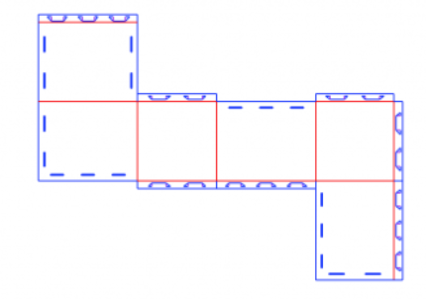
oBJECT | 1

1. OBJECT

The vision of this project is to create an interface that allows for the easy design of a robotic system without the need for a technical background, or the commitment of large amounts of time or money, in order to open up the design and creation of robots to a wider audience.

Introduction | 2

2. INTRODUCTION

Creating personal robotic devices is still a task that can be seen as foreign by the average person without any background on robotics, time, and financial resources. The vision of this research group is to develop a user interface that will create a robotic system with the user specified parameters without the user’s need to know any technical or background details about how it was created. This system is composed of parameters that need to be fulfilled in order to develop the integration for a program that will help us achieve our goal. So far, in the laboratory there is a python based interface that is been worked on to be able to achieve the vision. Currently, such interface allows users to create new tabs that can be used to create or modify mechanical components, base code components, or composite components. By allowing the user to alter or create such components, the user is able to work on different parts of the robot at the same time. Even though this is the progress that has been made so far, the Robot Compiler team (RoCo) has decided such structure results problematic and it would be better if the three interfaces were connected at a more fundamental level.

Proposed research | 3

3. PROPOSED RESEARCH

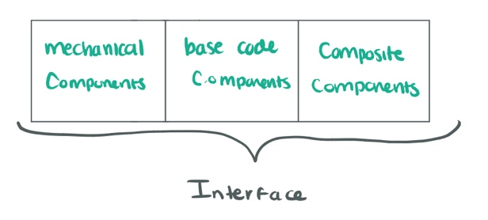
In order to better explain the difficulties faced by having an interface that allows users to create new tabs that can be used concurrently to create or modify mechanical components, base code components, or composite components we can refer to a simple example. Given an instance where a user creates a robot and decides to add a servo to the composite component interface, this would not change the way the interface understands the robot as a whole. The servo would appear in the composite component interface, but the servo mount would not appear in the mechanical interface. In order for the design to make sense, the robot must appear in the mechanical interface and have a mount as well.
This creates more issues such as the following:
-If a user simultaneously works on multiple mechanical components, How does the interface know which tab to add a component to?
-If a user adds a component mount to a mechanical component, which composite component interface would have such component added to it?
Such scenario becomes more complicated if the user simultaneously makes multiple robots.
Going back to the vision for this project, in order to develop an interface for users to create their own robot with the desired specifications, we need to divide this into two main parts: integration and characterization. The focus of my research will be mostly in the integration part of it keeping in mind that such interface must be created to be automatic and user should not need to have any background expertise on what they are asked for when constructing their design. Following up with the interface that is already developed, we need to work on making sure that such scenarios as the one presented early are done without any of the complications that we currently experience. For this, I propose that a new additional RoCo development new infrastructure needs to be produced to figure out where connections should be made depending on the addition of new elements. It must be clear that if new connections need to be made, the interface knows exactly how to generate and manufacture such traces.

wEEKLY PLAN | 4

4. WEEKLY PLAN

Week 4: October 23rd- October 29
- Meet up with RoCo team to further discuss details of project
- Meet up with Katya to discuss overlap of project and narrow down individual goals
- Obtain paper that is currently being worked on by Weber Chi (STILL PENDING)
- Continue Python tutorials
- Finish up location code using Python
- Make a list of necessary materials and have order ready by end of week
- -Finish proposal
Week 5: October 30th- November 5th
- Learn how to use paper cutter machine
- Build finger snapper design from RoCo using fishing rod
- Do extensive research on current RoCo project and try to adhere to the already existing code
- Get familiar with KiCAD
- Upload blogpost with simple schematic

- Week 6/7: November 6th- November 19th
- Research KiCAD deeply
- Work on more models until comfortable with platform
- Work on characterization
- Begin using different materials to work on design
- Develop electronic traces
- Work on infrastructure so that software will match architecture
Week 8: November 20th- November 26th
- Create a schematic for prototype using KiCAD
Week 9/10: November 27th- December 4th
- Create PCB layout traces for robot design
- Finish up layout
- Finish up robot design

